Work Manager v1.1

Ho Chi Minh, November 2016

Team Position:

Name | Position
Nguyen Phuong Hieu | Leader - Developer
Nguyen Anh Hoan | Developer
Nguyen Thi Mai Ly | Bussiness Analyst
Vo Minh Chau | Developer
Nguyen Ngoc Xuan Anh | Tester
Bui Nguyen Son Tung | Developer

- Model overview
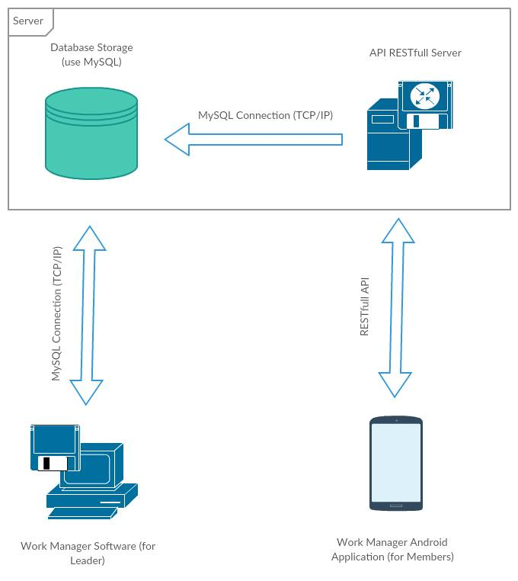
Description:
-Server: include database management system and RESTful API service
-Client: include Manager application for leasder and Android application for members

- Server
Overview:
-OS: Windows Server 2008 R2 (x64)
-DBMS: MySQL
-RESTful API:
+Web service: Apache
+Programming language: PHP
+Framework: Laravel

- Database Management System
SQL Script to init database:
SQL Script Init Database:
DROP DATABASE WorkManager;
CREATE DATABASE WorkManager DEFAULT CHARACTER SET utf8;
USE WorkManager;

CREATE TABLE Teams
(
TeamId INT AUTO_INCREMENT PRIMARY KEY,
Name VARCHAR(255)
);
CREATE TABLE Users
(
UserId INT AUTO_INCREMENT PRIMARY KEY,
Phone VARCHAR(20),
Name VARCHAR(255),

CONSTRAINT UC_Users_Id UNIQUE (Phone)
);
CREATE TABLE Members
(
MemberId INT AUTO_INCREMENT PRIMARY KEY,
TeamId INT,
UserId INT,

CONSTRAINT FK_Members_TeamId FOREIGN KEY (TeamId) REFERENCES Teams(TeamId),
CONSTRAINT FK_Members_UserId FOREIGN KEY (UserId) REFERENCES Users(UserId)
);
CREATE TABLE Tasks
(
TaskId INT AUTO_INCREMENT PRIMARY KEY,
TeamId INT,
UserId INT,
Title VARCHAR(255),
Descript TEXT,
Begin DATE,
End DATE,
Status TINYINT DEFAULT 0,

CONSTRAINT FK_Tasks_TeamId FOREIGN KEY (TeamId) REFERENCES Teams(TeamId),
CONSTRAINT FK_Tasks_UserId FOREIGN KEY (UserId) REFERENCES Users(UserId)
);
CREATE TABLE Tokens
(
TokenId INT AUTO_INCREMENT PRIMARY KEY,
UserId INT,
VerifyCode VARCHAR(6),
Token VARCHAR(32),

CONSTRAINT FK_Tokens_UserId FOREIGN KEY (UserId) REFERENCES Users(UserId)
);

- RESTful API
- Log In:
+URL: https://wm.geevoo.com/login/<phone number>
+Mothod: GET
+Result(JSON):
{
"status" : <true | false : boolean>,
"userid" : <user id number : integer>
}

-Verify Phone Number:
+URL:
https://wm.geevoo.com/verify/<user id number>/<verify code : string[6]>
+Method: GET
+Result(JSON):
{
"status" : <true | false : boolean>,
"userid" : <user id number : integer>,
"token" : <token string : string[32]>
}

-Get task list
+URL:
https://wm.geevoo.com/tasks/<user id number>/<token : string[32]>
+Method: GET
+Result (JSON):
{
"status" : <true | false : boolean>,
"tasks" : [
{
"id": <task id : integer>,
"name": <task name : string>,
"descript": task description : string>,
"team": <team name : string>,
"begin": <begin date : string>,
"end": <end date : string>
},
..
]
}

-Set seen task:
+URL:
https://wm.geevoo.com/seens/<user id number>/<token : string[32]>/<task id : array(integer)>
+Method: SET
+Result (JSON):
{
"status" : <true | false : boolean>}

